READINGS FOR THIS WEEK
CORNING PRAYER LIST
Liam Morstorf John Hawks
Mike Cruise Catie Hunter
Wayne Moore Doug Hardisty
Phyllis Brokaw Casey McKee
Ellen Gruba
8 SUN Is 58:7-10/1 Cor 2:1-5/Mt 5:13-16
FIFTH SUNDAY IN ORDINARY TIME
9 Mon 1 Kgs 8:1-7, 9-13/Mk 6:53-56
10 Tue 1 Kgs 8:22-23, 27-30/Mk 7:1-13
Saint Scholastica, Virgin
11 Wed 1 Kgs 10:1-10/Mk 7:14-23
Our Lady of Lourdes
12 Thu 1 Kgs 11:4-13/Mk 7:24-30
13 Fri 1 Kgs 11:29-32; 12:19/Mk 7:31-37
14 Sat 1 Kgs 12:26-32; 13:33-34/Mk 8:1-10
Saints Cyril, Monk, and Methodius, Bishop
15 SUN Sir 15:15-20/1 Cor 2:6-10/Mt 5:17-37 or 5:20-22a, 27-28, 33-34a, 37
SIXTH SUNDAY IN ORDINARY TIME

LENOX BIRTHDAYS
February 9 Javier Ferrer
February 12 Leticia Zapata

LENOX ANNIVERSARIES
February 14 Arturo & Melis Villarreal
February 15 Harlan & Lorraine Riley

CORNING BIRTHDAYS
February 8 Richard Hogan
February 11 Jamie Hogan

CORNING ANNIVERSARIES
February 15 John & Shirley Boswell

STEWARDSHIP REPORT
LENOX
Collection - $
Decembr Income - $15,267.00
Expenses - $8,492.40
CORNING
Collection – $

December Income - $ 34,220.87 ($21,450 is roof)
December Expenses - $ 12,918.34
Roof Campaign - $ 101,190.00

LITURGICAL ASSIGNMENTS

CORNING - SATURDAY, February 14
Rosary: John & Karma Green
Lector: Karma G.
EM: Marj R. & Karma G.
Ushers: Kathy W. & Anne G.
CORNING - SUNDAY, February 15
Rosary: Shirley B.
Servers: Mone, Rose & ean
Lector: Lara Crill
Em: Matt & Sheila R.
Sacristan: Julia P.
Ushers: Travis & Nora P.
Gift Bearers: Nate Ramsey Family
Musician:
Cantor: Tina H.
Money Counters Feb. 10: Bernadine & Barb F.

LENOX - SUNDAY, February 15
Sacristan: Judy
Lector: Ray & Larry
Servers: Chase & Diego
Ushers: Rick & Esther
Eucharistic Ministers: Kathy, Larry, Don
Money Counters: Larry & Ray
Power Point: Katherine
Coffee & Rolls:
Feb. 15: Valentine’s Day Breakfast by CYO
Feb. 22: Merlis V., Jose & Melissa V.



ST. PATRICK CATHOLIC CHURCHES

CORNING AND LENOX

www.stpatrickcorning.com

www.stpatricklenox.com

Fr. Livinus Anweting – Canonical Administrator

February 7-8, 2026

FIFTH SUNDAY IN ORDINARY TIME

St. Patrick, Corning
504 Grove Ave. • Corning, IA 50841
Father’s Email . . . . . lanweting@dmdiocese.org
Office Phone: . . . . . . . . . . . . . . . . . .641-322-3363
E-mail: . . . . . . . . . . . . . pat_corning@yahoo.com
Hall Rental: . . . . . . . . Rosie Bissell 712-621-0942
RE . . . . . . . . . . . . . .Danielle Colella 917-676-8873
Office Manager: .Jane Rychnovsky 641-344-4089
Prayer Chain: . . .Marcella Gearheart 641-322-3885

St. Patrick, Lenox
600 W. Michigan • Lenox, IA 50851
Father’s Email . . . . . lanweting@dmdiocese.org
Office Phone: . . . . . . . . . . . . . . . . . . .641-333-2565
Email: . . . . . . . . . . . . . . . . . . . . stpatl@lenoxia.com
Office Manager/RE: . . . . . . . . . . . . . Kathy Ecklin
Ministry of Caring: . . .Kathy Ecklin 641-333-2565 . . . . . . . . . . . . . . Marilyn Rychnovsky 641-335-2268

Visitation of the Sick - Please call the parish office in Corning - 641-322-3363 or Lenox - 641-333-2565 - to arrange for Communion in your home.

Confessions:
Lenox - Sunday,8:00 -8:30 a.m.
Corning - Saturday, 5:00p.m.-5:30 p.m. Available anytime upon request

ROSARY
Corning, Rosary Recitation every Tuesday at 11:00 a.m., before, NOON Mass, Saturday, 5: 00.pm. and Sunday at 10:00a.m.

Mass Schedule
C, Sat., Feb. 7 5:30 p.m. Richard & Irene
Weis
L, Sun., Feb. 8 8:30 a.m. Andrew Rychnovsky
C, Sun., Feb. 8 10:30 a.m. Anastasio &
Rafaela de Rosales
C, Tues., Feb. 10 12:00 (Noon) John Hogan
L, Wed., Feb. 11 8:30 a.m. Glen & Helen
Juelsgaard
C, Thurs., Feb. 12 12:00 (Noon) Joe Hatton
L., Fri., Feb. 13 8:30 a.m. Paul & Monica
Lynam
C, Sat., Feb. 14 5:30 p.m. Levi & Elizbeth
Green
L, Sun., Feb. 15 8:30 a.m. Mary Rychnovsky
C, Sun., Feb. 15 10:30 a.m. Richard Jennings

EXPOSITION OF BLESSED SACRAMENT
Corning, First Thurs: 5:30 p.m.-6:30 p.m.
Lenox, First Friday: 9.00.m.-10.00 a.m.

SACRAMENTS
Marriage - Arrangements should be made ASAP and at least six months before the wedding.
Baptism - Baptisms are held on the 3rd Sunday
Lenox, Rosary recitation every Wednesday and Friday after mass at 9:00 a.m. and Sunday at 8:00a.m.
REFLECTION

Fifth Sunday in Ordinary Time

In the Lord’s name, the prophet Isaiah exhorts the people to address the needs of the downtrodden, for it is then that the Lord will answer when they call. Paul writes to the Corinthians that he resolved to know nothing …except Jesus Christ, and him crucified. In the Gospel, Jesus tells his disciples they are the salt of the earth and the light of the world.

The just man is a light in darkness
to the upright.
At our baptism, we receive the light of Christ. While this light of faith certainly illumines our path, it is also meant to be shared with others. Through our good works, the light of Christ shines forth, helping others to recognize the work of God in our lives and drawing them to give him thanks and praise.


COMBINED ANNOUNCEMENTS

Ash Wednesday is February 18th. Mass times will be announced when Fr. Livinus returns from vacation.

FISH FRY DATES
February 27th 5:30-7:00 p.m. Lenox

March 13th 5:30-7:00 p.m. Corning
March 27th 5:30-7:00 p.m. Corning

CORNING ANNOUNCEMENTS

MEETINGS—February 10th
Liturgy at 4:30 p.m. in the Church office
Parish Council at 5:30 p.m. at Parish Center

FINANCE COUNCIL MEETING
Tuesday, February 17th at 5:30 p.m. at the Parish Center.

LENT and EASTER
Easter is approaching. Please check the Bulletin, Liturgical Assignments, Mass Intensions and Facebook for all upcoming information. We will no longer be asking for volunteers to sign up for assignments for holiday masses. These sign-up sheets do not get filled out and we end up contacting people to complete all the duties for these special masses. If there are certain Masses you can’t attend please contact her well in advance. She does a great job of distributing duties for each month.

CORNING PRAYER LIST
Liam Morstorf Mary Moore Cathy Luther
Catie Hunter Casey McKee Doug Hardisty Ben Schweers Hank Sorensen Dash Burr
John Hawks Karen Taylor Kathy Hogan
Marcella Gearheart

LENOX PRAYER LIST

Irene Ripperger Kenny Heim Nathan Harms
John Heim Camilla Perez Elvira Meny
Rachael Reed Paul Maynes Ben Schweers
Sergio Dozier Leslie Cerda Brandon Larimer
Stacy Callahan Brown Jack Wackernagle
David Hale Ben French Mary O'Riley
Michael Gray Wayne Haidsiak Andrea Rayhons
Cyrila Roberts

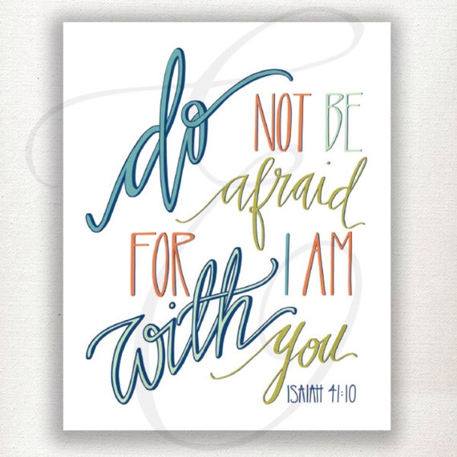

LENOX ANNOUNCEMENTS

FISH FRY UPDATE
Menu: Cod fish, smoked baked beans, coleslaw,
mac n cheese, dinner roll, assorted desserts, tea,
and lemonade. Freewill Donation. Carry Out but
no deliveries. Friday, February 27th from 5:30 –
7:00 p.m. Corning Knights of Columbus will be
cooking the cod, but anyone from Lenox is
welcome to help them. We are excited about
offering this meal to the Lenox and surrounding
communities.

FOOD BAGGING
Our next food bagging will be Wed., Feb. 11th at
6:00 p.m. 5th graders - adults are invited to come
And help. Meals stay in the Lenox and surrounding
communities. Pasta with Tomato Basil Sauce
and Raisin Cinnamon Oatmeal are the two meals
we are going to bag.

SOCKS OF LOVE
There are socks in the back of the church for you
to take a pair. Fill them with toiletry products and
return to Kathy by the end of February. These
socks will be taken to Des Moines and passed out
to the homeless.

LENTEN ECHUMENICAL SERVICES
We will host the first Lenten service on Sunday,
February 22 at 5:00 p.m. Committee members are
Joyce S., Marilyn R., Deanna S., Martha M., Ag C.,
Melissa S., Lahni Jean R., and Kristen R.

