READINGS FOR THIS WEEK
CORNING PRAYER LIST
Liam Morstorf John Hawks
Mike Cruise Catie Hunter
Wayne Moore Doug Hardisty
Phyllis Brokaw Casey McKee
Ellen Gruba

14 SUN Is 35:1-6a, 10/Jas 5:7-10/Mt 11:2-11
THIRD SUNDAY OF ADVENT
15 Mon Nm 24:2-7, 15-17a/Mt 21:23-27
16 Tue Zep 3:1-2, 9-13/Mt 21:28-32
17 Wed Gn 49:2, 8-10/Mt 1:1-17
18 Thu Jer 23:5-8/Mt 1:18-25
19 Fri Jgs 13:2-7, 24-25a/Lk 1:5-25
20 Sat Is 7:10-14/Lk 1:26-38
21 SUN Is 7:10-14/Rom 1:1-7/Mt 1:18-24
FOURTH SUNDAY OF ADVENT

LENOX BIRTHDAYS
December 14 Jeanine Lynam
December 14 Linos Padilla
December 15 Karleen Stephens
December 18 Pat Robinson

LENOX ANNIVERSARIES

CORNING BIRTHDAYS
December 15 Pat Venteicher
December 17 Janean Maeder
December 19 Bethal Kopp
December 20 Ellie Amdor
December 20 Ed Schweers

CORNING ANNIVERSARIES

STEWARDSHIP REPORT
LENOX
Collection - $ 1,816.00
NOVEMBER INCOME - $6,256.00
EXPENSES - $5,779.06
CORNING
Collection – $ 2180.00
November Income - $ 23,604.21 ($10,425 is roof)
November Expenses - $ 12,014.53
Roof Campaign - $ 97,390.00

LITURGICAL ASSIGNMENTS

CORNING - SATURDAY, December 20
Rosary: John & Karma Green
Lector: Karma G.
EM: John & Karma
Ushers: Anne G. & Maj R.
CORNING - SUNDAY, December 21
Rosary: Kris Richey
Servers: Reagan, Laney & Milena
Lector: Sarah Morrison
Em: Matthew & Sheila R.
Sacristan: Sarah M.
Ushers: Barb F. & Kathy W.
Gift Bearers: Travis Paul Family
Musician: Marilea
Cantor: Nancy
Money Counters Dec. 16: Jackie & Rosie

LENOX - SUNDAY, December 21
Sacristan: Kathy
Lector: Larry & Ray
Servers: Katherine & Camilla
Ushers: Halee & girls
Eucharistic Ministers: Don, Mike, Brian
Money Counters: Brad & Rick
Power Point: Brayden
Coffee & Rolls:
Dec. 21: Doc & Donna H, Duane H, Roger &
Barb H

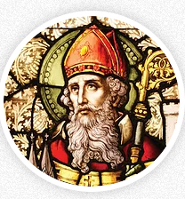
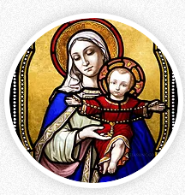
ST. PATRICK CATHOLIC CHURCHES

CORNING AND LENOX

www.stpatrickcorning.com

www.stpatricklenox.com

Fr. Livinus Anweting – Canonical Administrator

December 13-14, 2025

THIRD SUNDAY OF ADVENT

St. Patrick, Corning
504 Grove Ave. • Corning, IA 50841
Father’s Email . . . . . lanweting@dmdiocese.org
Office Phone: . . . . . . . . . . . . . . . . . .641-322-3363
E-mail: . . . . . . . . . . . . . pat_corning@yahoo.com
Hall Rental: . . . . . . . . Rosie Bissell 712-621-0942
RE . . . . . . . . . . . . . .Danielle Colella 917-676-8873
Office Manager: .Jane Rychnovsky 641-344-4089
Prayer Chain: . . .Marcella Gearheart 641-322-3885

St. Patrick, Lenox
600 W. Michigan • Lenox, IA 50851
Father’s Email . . . . . lanweting@dmdiocese.org
Office Phone: . . . . . . . . . . . . . . . . . . .641-333-2565
Email: . . . . . . . . . . . . . . . . . . . . stpatl@lenoxia.com
Office Manager/RE: . . . . . . . . . . . . . Kathy Ecklin
Ministry of Caring: . . .Kathy Ecklin 641-333-2565 . . . . . . . . . . . . . . Marilyn Rychnovsky 641-335-2268

Visitation of the Sick - Please call the parish office in Corning - 641-322-3363 or Lenox - 641-333-2565 - to arrange for Communion in your home.

Confessions:
Lenox - Sunday,8:00 -8:30 a.m.
Corning - Saturday, 5:00p.m.-5:30 p.m. Available anytime upon request

ROSARY
Corning, Rosary Recitation every Tuesday at 11:00 a.m., before, NOON Mass, Saturday, 5: 00.pm. and Sunday at 10:00a.m.

Mass Schedule
C, Sat., Dec. 13 5:30 p.m. Theresa Durkin
L, Sun., Dec. 14 8:30 a.m. Alex Stephens
C, Sun., Dec. 14 10:30 a.m. Geronimo Reyna
L, Sun, Dec. 14 1:00 p.m. People of our Parish
C, Tues., Dec. 16 12:00 (Noon)
L, Wed., Dec. 17 8:30 a.m. Henry Rayhons
C, Thurs., Dec. 18 12:00 (Noon)
L., Fri., Dec. 19 8:30 a.m. Don Chapman
C, Sat., Dec. 20 5:30 p.m.
L, Sun., Dec. 21 8:30 a.m. Jim Wurster
C, Sun., Dec. 21 10:30 a.m.

EXPOSITION OF BLESSED SACRAMENT
Corning, First Thurs: 5:30 p.m.-6:30 p.m.
Lenox, First Friday: 9.00.m.-10.00 a.m.

SACRAMENTS
Marriage - Arrangements should be made ASAP and at least six months before the wedding.
Baptism - Baptisms are held on the 3rd Sunday
Lenox, Rosary recitation every Wednesday and Friday after mass at 9:00 a.m. and Sunday at 8:00a.m.

REFLECTION
It was coming up to Christmas and Sammy asked his mum if he could have a new bike. So, she told him that the best idea would be to write to Santa Claus. But Sam, having just played a vital role in the school nativity play, said he would prefer to write to the baby Jesus. So, his mum told him that would be fine.
Sam went to his room and wrote ' Dear Jesus, I have been a very good boy and would like to have a bike for Christmas.' But he wasn't very happy when he read it over. So, he decided to try again and this time he wrote 'Dear Jesus, I'm a good boy most of the time and would like a bike for Christmas.' He read it back and wasn't happy with that one either. He tried a third version. 'Dear Jesus, I could be a good boy if I tried hard and especially if I had a new bike.' He read that one too, but he still wasn't satisfied.
So, he decided to go out for a walk while he thought about a better approach. After a short time, he passed a house with a small statue of the Virgin Mary in the front garden. He crept in, stuffed the statue under his coat, hurried home and hid it under the bed. Then he wrote this letter. 'Dear Jesus, if you want to see your mother again, you'd better send me a new bike.'
In the first reading of this Sunday the prophet Isaiah exalts us to be joyful because God himself is coming to save us his people. He says to us: “Courage! Do not be afraid, look your God is coming.” Our God being a generous God will come with lots of gifts and goodies. Just as Sammy expected, Jesus is sending us a “new bike” – a renewing gift of joy. He is the “Real Father Christmas Par Excellence,” when it comes to dishing out gifts of wellbeing to his people.
Hence, the prophet lets the cat out of the bag for us concerning what the Lord will bring when he comes: “Then the eyes of the blind shall be open, ears of the deaf unsealed…for those the Lord has ransomed shall return.” Most important of all these is the joy that will accompany the Lord’s coming with which his people who waited patiently and faithfully shall be filled to overflowing: “They will come to Zion shouting for joy, everlasting joy on their faces; joy and gladness will go with them and sorrow and lament ended.” With expectant waiting like Sammy in our story, the joy that fills our heart today is only a foretaste of that which we are to experience when Jesus comes. It is only a tip of the iceberg and a sign that the future is bright with lots of prospects for us in Christ.

COMBINED ANNOUNCEMENTS

FR. LIVINUS PRIESTLY ANNIVERSARY
December 18th is Fr. Livinus anniversary of being ordained a priest. Say a prayer for him. Join him at noon mass that day in Corning.

CHRISTMAS MASS SCHEDULES

Christmas Eve: Corning 7:30 p.m.
Lenox 5:30 p.m.
Christmas Day Corning 10:30 a.m.
Lenox 8:30 a.m.
New Year’s Day Corning 10:30 a.m.
Lenox 8:30 a.m.
Christmas Mass is a Holy Day of Obligation so please take the time to attend one of the Christmas Masses that are offered here or wherever you are celebrating this special day.

MASS STIPENDS FOR 2026
A Diocesan change has been made for Mass Stipends. As of Jan. 1, 2026, the cost will be $10.00 per mass instead of the previous amount of $5.00

END OF YEAR GIVING
Remember our St. Patrick parish in your year end
Giving. We need more funds to run our church.

CORNING ANNOUNCEMENTS

KIDS CHRISTMAS PROGRAM
Today at 2 p.m. at the Parish Center

ADVENT TRIVIA
Wednesday, December 17 at 6-7:30 p.m.

SIGN-UP SHEETS
The time is drawing near, please put your name down on the sheet at the back of the church for Liturgical Duties throughout this holiday season.

CHURCH CLEANING 2026
There is a sign-up sheet at the back of the church for 2026 Church cleaning schedule along with the 2025 sheet for reference.

DECORATING & HOMEBOUND
Thanks to Rosie and Jane who were the only ones here to decorate the rectory and prepare cups for our homebound.

CHRISTMAS ANGELS
Thanks to everyone who took a tag off our tree for Christmas Angels. Gifts should be returned by December 15th and placed in the boxes provided at the back o0of the church. If you would like to make a cash donation, feel free to send a check to: AC Christmas Angels, c/o Union State Bank, 701 Benton Avenue, Corning, IA 50841.

NEW MEMBERS
Please pray for Rebecca Grahn, Nate Ramsey, and Lane Peterson as they begin the OCIA program in our church. Keep them in your prayers as they prepare for full communion and the reception of the Sacraments at Easter 2026.
LENOX PRAYER LIST

Irene Ripperger Kenny Heim Nathan Harms
John Heim Camilla Perez Elvira Meny
Rachael Reed Paul Maynes Ben Schweers
Sergio Dozier Leslie Cerda Brandon Larimer
Stacy Callahan Brown Jack Wackernagle
David Hale Ben French Mary O'Riley
Michael Gray Bill Riley Troy Bauer
Andrea Rayhons

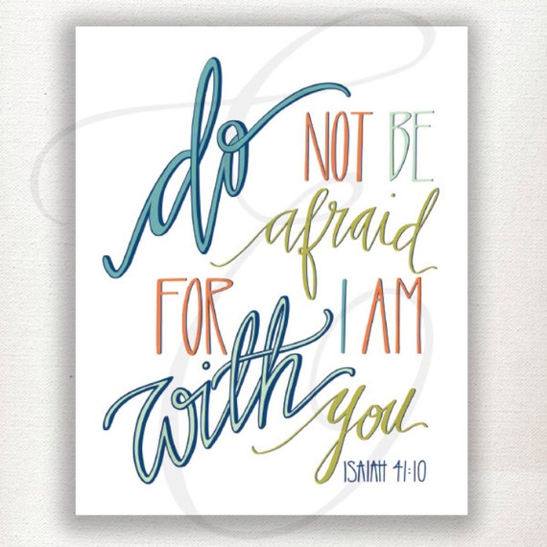

CORNING PRAYER LIST
Liam Morstorf Mary Moore Mike Cruise
Catie Hunter Casey McKee Doug Hardisty Ben Schweers Hank Sorensen Dash Burr
John Hawks Kathy Konecne

LENOX ANNOUNCEMENTS

EVENING IN BETHLEHEM
TODAY at 5:00 p.m. Come join us in Bethlehem
for a meal and faith filled activities.

SPANISH MASS – Today at 1:00 p.m. and Sunday, December 28th.
THANK YOU - To everyone who participated in Sunday's workday. The list was long, but almost everything got checked off!
COOKIE CARNIVAL - The cookies and candies were absolutely wonderful that people made. Cookie sales totaled $997.00 and there are no cookies left! Thank you to all our cookie/candy bakers, to the December committee and to all the cookie buyers.
ANGEL TREE - All 23 children's names have been taken off the tree. Thank you to all who are shopping for Christmas gifts. Please have them back to the church by Wednesday, December 17th. A special Thank you to Brad, Sarah, and Katherine Adamson, Jose, Janet, Brayden, Jase and Jaidy Lopez, Rick Martinez, Deigo Zamora, Chase Sonntag, and Ariel Villarreal who went shopping for 10 children on Sunday.
CHURCH DECORATING - We will decorate for Christmas after Mass on Sunday, December 21rst. Everyone invited to help.

