READINGS FOR THIS WEEK
CORNING PRAYER LIST
Liam Morstorf John Hawks
Mike Cruise Catie Hunter
Wayne Moore Doug Hardisty
Phyllis Brokaw Casey McKee
Ellen Gruba
25 SUN Ex 22:20-26/1 Thes 1:5c-10/Mt 22:34-40
30TH SUNDAY IN ORDINARY TIME
26 Mon Eph 4:32—5:8/Lk 13:10-17
27 Tue Eph 5:21-33/Lk 13:18-21
28 Wed Eph 2:19-22/Lk 6:12-16
Saints Simon and Jude, Apostles
29 Thu Eph 6:10-20/Lk 13:31-35
30 Fri Phil 1:1-11/Lk 14:1-6
31 Sat Phil 1:18b-26/Lk 14:1, 7-11
1 SUN Rv 7:2-4, 9-14/1 Jn 3:1-3/Mt 5:1-12a
ALL SAINTS DAY

LENOX BIRTHDAYS

LENOX ANNIVERSARIES

CORNING BIRTHDAYS
October 28 Savannah Laughlin
October 31 Mondra Laughlin
November 1 Travis Paul
November 1 Marcella Gearheart

CORNING ANNIVERSARIES

5

STEWARDSHIP REPORT
LENOX
Tithing - $ 9,951.83
Boiler - $3,000.00
September expenses - $12,603.15
September income - $12,546.00
CORNING
Collection – $ 1,230.00
EFT - $ --0.00
September Income - $ 17,816.60
September Expenses - $ 9,999.99
Roof Expenses - $146,865.00

LITURGICAL ASSIGNMENTS

CORNING - SATURDAY, October 31
Rosary: John & Karma G.
Lector: Lisa Allison
EM: Doug & Lisa
Ushers:. Marj & Nicky

CORNING - SUNDAY, November 1
Rosary: Jamie H.
Servers: Sean, Finn & Gwen
Lector: Mark R.
Em: Mark & Jamie
Sacristan: Julia
Ushers: Barb & Nicky
Gift Bearers: Travis Paul Family
Musician:
Cantor: Tina
Money Oct. 27 Rosie & Janean

LENOX - SUNDAY, November 1
Sacristan: Kathy
Lector: Youth Mass
Servers: Youth Mass
Ushers: Youth Mass
Eucharistic Ministers: Sarah, Brian, Kathy
Money Counters: Brad & Michelle
Power Point: Youth Mass
Coffee & Rolls: Oct. 25: Jen W., Cathy W., Lynn M.
Nov. 1: Mike & Janet V.; Paul & Brenda R.

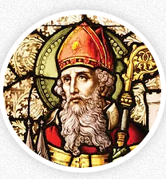
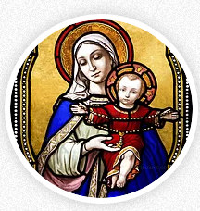
ST. PATRICK CATHOLIC CHURCHES

CORNING AND LENOX

www.stpatrickcorning.com

www. sites.google.com/view/st-patrick-lenox/

Fr. Livinus Anweting – Canonical Administrator

October 24-25, 2026

THIRTIETH SUNDAY IN ORDINARY TIME

St. Patrick, Corning
504 Grove Ave. • Corning, IA 50841
Father’s Email . . . . . lanweting@dmdiocese.org
Office Phone: . . . . . . . . . . . . . . . . . .641-322-3363
E-mail: . . . . . . . . . . . . . pat_corning@yahoo.com
Hall Rental: . . . . . . . . Rosie Bissell 712-621-0942
RE . . . . . . . . . . . . . .Danielle Colella 917-676-8873
Office Manager: .Jane Rychnovsky 641-344-4089
Prayer Chain: . . .Kathy Morrison 641-344-2535

St. Patrick, Lenox
600 W. Michigan • Lenox, IA 50851
Father’s Email . . . . . lanweting@dmdiocese.org
Office Phone: . . . . . . . . . . . . . . . . . . .641-333-2565
Email: . . . . . . . . . . . . . . . . . . . . stpatl@lenoxia.com
Office Manager/RE: . . . . . . . . . . . . . Kathy Ecklin
Ministry of Caring: . . .Kathy Ecklin 641-333-2565 . . . . . . . . . . . . . . Marilyn Rychnovsky 641-335-2268

Visitation of the Sick - Please call the parish office in Corning - 641-322-3363 or Lenox - 641-333-2565 - to arrange for Communion in your home.

CONFESSIONS:
Corning - Saturday, 5:00p.m.-5:30 p.m. Lenox – Sundays, 8:00 a.m. – 8:30 a.m.
Available anytime upon request

ROSARY
Corning, Rosary Recitation Saturday, 5: 00.pm. and Sunday at 10:00a.m.

Mass Schedule
C, Sat., Oct. 24 5:30 p.m. Theresa Cruise
L, Sun., Oct. 25 8:30 a.m. Paul & Monica Lyman
C, Sun., Oct. 25 10:30 a.m. John Hogan
C, Tues., Oct. 27 12:00 (Noon) Albert & Clara
Hogan
L, Wed., Oct. 28 8:30 a.m. Don Chapman
C, Thurs., Oct. 29 12:00 (Noon) Kristin Ledvina
L, Fri., Oct. 30 8:30 a.m. Mike Skahill
C, Sat., Oct. 31 5:30 p.m. Robert Kuhl
L, Sun., Nov. 1 8:30 a.m. Jim Votava
C, Sun., Nov. 1 10:30 a.m. Geronimo Reyna SR

EXPOSITION OF BLESSED SACRAMENT
Corning, First Thurs: 5:30 p.m.-6:30 p.m.
Lenox, First Friday: 9.00.m.-10.00 a.m.

SACRAMENTS
Marriage - Arrangements should be made ASAP and at least six months before the wedding.
Baptism - Baptisms are held on the 3rd Sunday
Lenox, Rosary recitation every Wednesday and Friday after mass at 9:00 a.m. and Sunday at 8:00a.m.

REFLECTION
On this 30th Sunday in ordinary time, the Book of Exodus describes how God formed the Israelites into a people after freeing them from slavery in Egypt. After receiving the Ten Commandments, they were given further laws to guide their life as a community. Today’s first reading focuses on protecting strangers, widows, orphans, and the poor, who were especially vulnerable in ancient society. The Israelites are reminded that they too were once strangers in Egypt and experienced oppression. Having suffered themselves, they must not allow others to suffer in the same way. God warns that He will hear the cries of widows and orphans when they are mistreated, thus revealing a God who does not remain distant from human suffering but stands with the vulnerable.
The passage also teaches that compassion must be practical. A person who lends money to the poor must not exploit their helplessness by charging interest. Even a poor person's cloak, taken as security for a loan, must be returned before sunset because it may be their only protection against the cold. Human dignity must always take priority over material gain.
This passage invites us to examine how we treat the vulnerable in our own society. Migrants, daily-wage workers, and struggling families may be easily ignored or exploited. Sometimes, we judge people without understanding their difficulties. Our faith is not measured only by how we pray, but also by how we treat those who have the least. God calls us to recognize the dignity of every person, stand up against injustice, and respond with compassion. The question we must ask ourselves is: Do our words and actions make life easier or more difficult for those who are already struggling?

En este 30.º domingo del tiempo ordinario, el libro del Éxodo describe cómo Dios convirtió a los israelitas en un pueblo después de liberarlos de la esclavitud en Egipto. Tras recibir los Diez Mandamientos, se les dieron más leyes para orientar su vida como comunidad. La primera lectura de hoy se centra en proteger a los extranjeros, las viudas, los huérfanos y los pobres, que eran especialmente vulnerables en la sociedad antigua. Se recuerda a los israelitas que ellos también fueron extranjeros en Egipto y sufrieron opresión. Habiendo sufrido ellos mismos, no deben permitir que otros sufran de la misma manera. Dios advierte que escuchará los clamores de las viudas y los huérfanos cuando sean maltratados, revelando así a un-Dios que no permanece distante del sufrimiento humano, sino que está al lado de los vulnerables.
El pasaje también enseña que la compasión debe ser práctica. Una persona que presta dinero a los pobres no debe aprovecharse de su indefensión cobrando intereses. Incluso el manto de una persona pobre, tomado como garantía de un préstamo, debe devolverse antes del atardecer porque puede ser su única protección contra el frío. La dignidad humana siempre debe tener prioridad sobre la ganancia material.
Este pasaje nos invita a examinar cómo tratamos a las personas vulnerables de nuestra propia sociedad. Los migrantes, los trabajadores que cobran un salario diario y las familias que atraviesan dificultades pueden ser fácilmente ignorados o explotados. A veces, juzgamos a las personas sin comprender sus dificultades. Nuestra fe no se mide solo por cómo oramos, sino también por cómo tratamos a quienes menos tienen. Dios nos llama a reconocer la dignidad de cada persona, a alzarnos contra la injusticia y a responder con compasión. La pregunta que debemos hacernos es: ¿Nuestras palabras y acciones hacen la vida más fácil o más difícil para quienes ya están pasando por dificultades?

COMBINED ANNOUNCEMENTS

HOLY DAYS
ALL SAINTS DAY is Sunday, November 1, we will celebrate at our regular Sunday mass times. This is a Holy Day of Obligation.
ALL SOULS DAY is Monday, November 2nd. Masses for All Souls Day will be at 8:30 a.m. in Lenox and 5:30 p.m. in Corning.

CORNING ANNOUNCEMENTS

CHILI SUPPER
The Adams County Ministerial Association hosted a chili supper on October 23rd at the Parish Center. Thanks to Barb Fuller for helping with the chili and Steve Gruba who organized this much-needed fundraiser. Proceeds will go to churches to help those in need in Adams County.

MEALS ON WHEELS—OCTOBER
26th & 27th Anna Mealey;
28th Bill & Kathy; 29th Kathy West;
30th Nancy Amdor.

REMEMBERING THE SOULS OF OUR FAITHFULLY DEPARTED LOVED ONES
The book is on the table at the entrance of the church for you to add names of family members you would like to have remembered at masses in November. This book will be caried to the altar with gifts of bread and wine.

CONGRATULATIONS
Please say an extra prayer for Olivia & Lane as they prepare for their wedding ceremony on November 7th in Olivia’s home church. Congratulations to them.

ALTAR SOCIETY
Due to the General Election, Altar Society will meet on Monday, November 9th at 5:00 p.m.

NOVEMBER MEETINGS
Mark your calendars for November 10th for Liturgy, Parish Council and Finance meetings.
LENOX PRAYER LIST
Irene Ripperger Nathan Harms John Heim Camilla Perez Elvira Meny Rachael Reed Paul Maynes Ben Schweers Sergio Dozier Leslie Cerda Brandon Larimer Jack Wackernagle David Hale Ben French Arturo Villarreal
Mary O'Riley Wayne Haidsiak Andrea Rayhons
Margarita Zapata Debbie Bradley Colleen Cruise
San Juana Macias

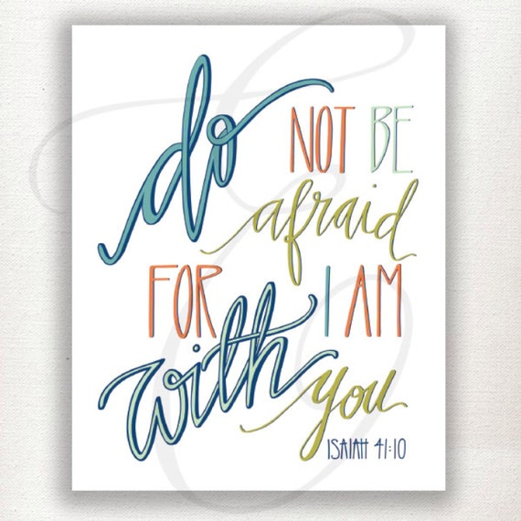

CORNING PRAYER LIST
Liam Morstorf Mary Moore Cathy Luther
Catie Hunter Casey McKee Doug Hardisty Ben Schweers Hank Sorensen Dash Burr
John Hawks Kathy Hogan Deborah K Piper
Marcella Gearheart Christopher Black

LENOX ANNOUNCEMENTS

CONFIRMATION
Regular Class - Diego -Host - 6:15 p.m.
ADORATION
We will have Adoration, Wednesday, November 4th at 6:30 p.m. This will be geared towards our youth, but all are welcome to come and spend some time with our Lord.
DECEASED LOVED ONES
There is a book at the entrance of the church for you to write deceased loved ones in. The book will be carried during offertory to altar and remainthroughout the month of november.

THANK YOU - To everyone who came out for our Fall Family Night. The evening was perfect for a hayride and carving of pumpkins using the pumpkin prayer.
OCTOBER ROSARY
Weekday and Sunday rosary will be said for all families in our parish. Names will be on the altar and also announced before each rosary is said. The rosary is prayed every Sunday morning at 8:00 a.m. and after our weekday masses.

PRAYER CARDS - Father has blessed prayer cards in both entrances of the church. Each prayer card has a Confirmadi's name on it. Please take one or more and pray for them this year as they continue their faith journey.

